Update May 2023

Dear Parent(s)/Guardian(s),
We are now approaching the final few weeks of this academic year. This time of year is extremely busy in a primary school with so many events happening between now and the end of June.
Please keep an eye on the school website calendar – we try to keep it continually updated.

Primary Seven
Our P7 pupils have their last day on Friday 23rd June. This will be a full school day.
On Thursday 22nd June, the parents of our P7 pupils will be invited to a celebration to mark the end of their child’s time in St Malachy’s P.S. This will take place in our assembly hall.
There will be a leavers Mass at 10.00am in St Malachy’s Chapel, Carrickcruppen, on Friday 23rd June and parents are welcome to attend. More details will follow.
P7 pupils will receive details of their school placement for next year by email on Saturday 20th May.
St Paul’s H.S transition day takes place on Tuesday 13th June.

Sports Days
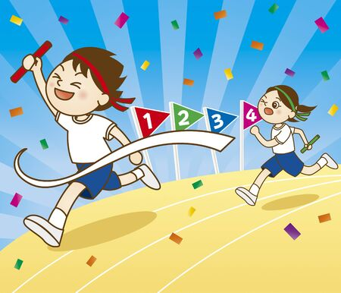
This year we will be having two sports days. The first will be on Tuesday 6th June, beginning at 9.45am in our back field. This will be for P1, P1/2, P2 and all P3 pupils. Parents are welcome to attend.
The second sports day will take place on Friday 9th June in Shane O’Neill’s GAC and will begin at 9.45am. This will be for the pupils in P4(OW), P4/5, P5, P6, P6/7 and P7. Parents are welcome to attend. (We hope to be able to use the facilities at Carrickcruppen GAC the following year.)
More details about these days will follow.

School Trips
All of our school trips have been booked. Please check the calendar on our website for dates.

Local Election
Please remember that the school will be closed on Thursday May 18th due to being used as a polling station.
We will also be closed on Friday 26th and Monday 29th May for the last bank holiday.

Reports
Your child’s end of year report, along with details of their class and teacher for the following year, will be sent home with your child on Friday 23rd June. P7 pupils will receive their report earlier that week.

Parent Evening
There will be an information evening for the parents of next year’s nursery pupils and next year’s P1 pupils on Tuesday 6th June – more details to follow.
Uniform
Our new uniform will soon be available at the usual outlets. Children will be able to wear any items of the existing school uniform until a new uniform is required.

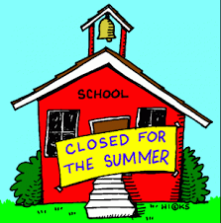

School finishes for the summer holidays on Friday 30th June at 12 noon. There will not be dinners or afternoon buses on this day. Our school will reopen after the summer break on Friday 1st September.
As another year draws to a close, I would like to thank you for your continued support. Our school continues to flourish and we are blessed with happy children who are eager to learn. We appreciate all you do to help us, help your children.

Le meas,
Pauline McEvoy
Principal.

