The Story of Holy Week

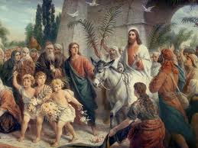 | 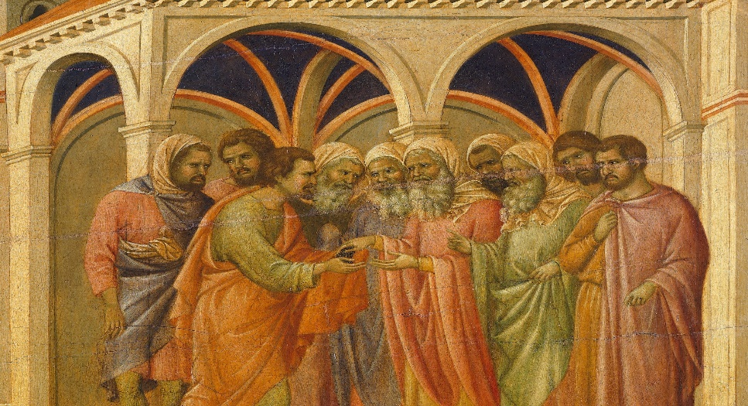
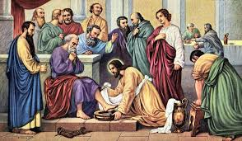 | 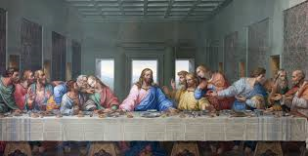
 | 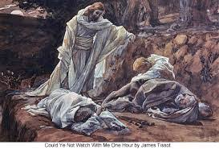
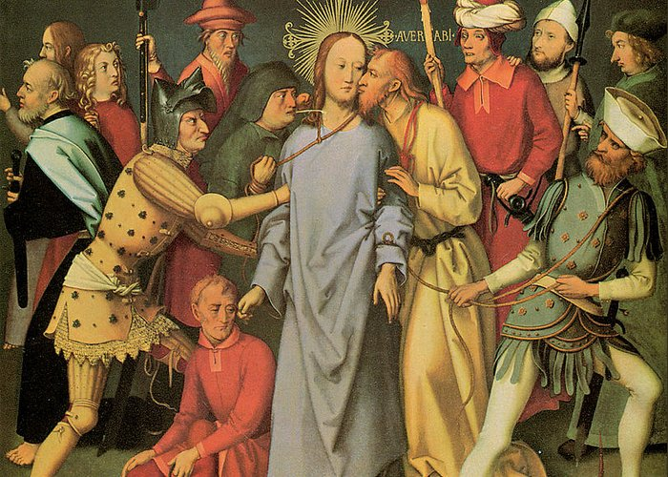

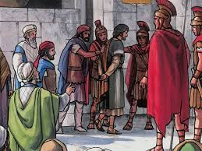 | 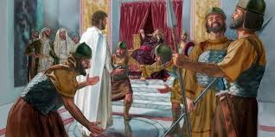
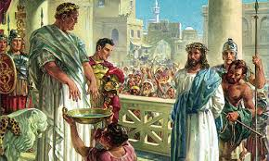 | 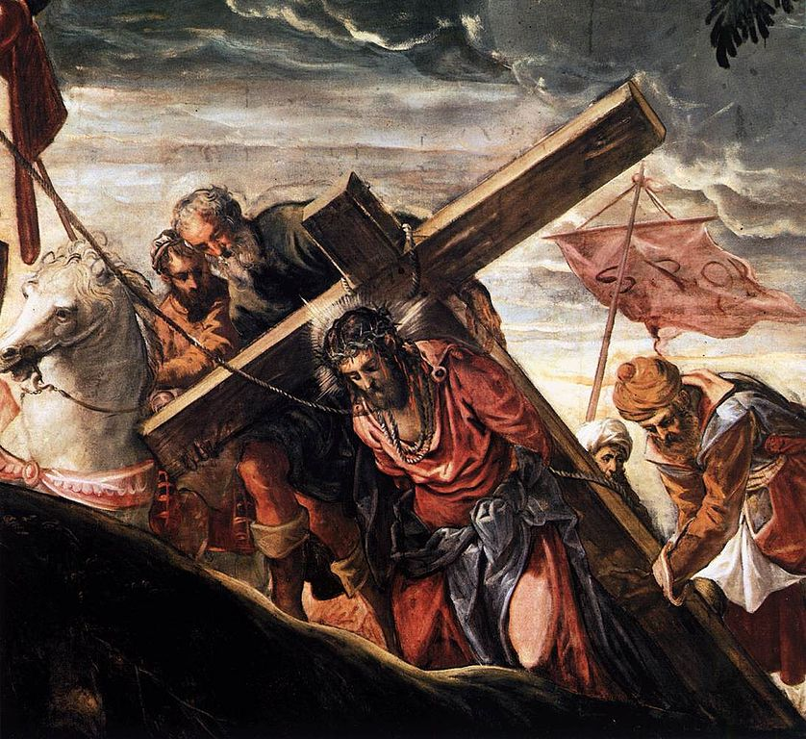

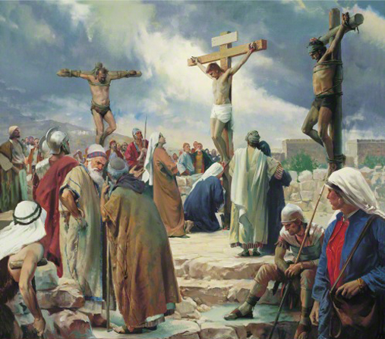

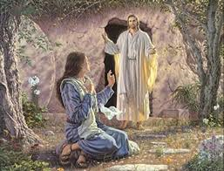 | 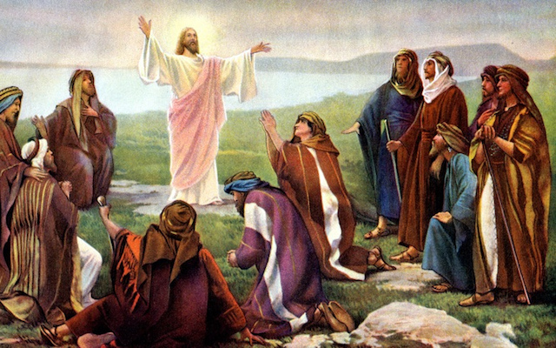

Palm Sunday – Jesus enters Jerusalem  Spy Wednesday – Judas agrees to betray Jesus  Holy Thursday – Jesus washes the disciples’ feet  Jesus shares the Last Supper with his disciples – Judas leaves  Jesus prays to His Father in the Garden of Gethsemane  The disciples fall asleep while protecting Jesus  Judas betrays Jesus with a kiss and Jesus is arrested  Jesus appears before the High Priest Caiaphas | Good Friday - Jesus appears before Pilate for the first time  Jesus is sent to stand before Herod  Jesus is tried before Pilate and sentenced to death  Jesus is made to carry his cross  Jesus is crucified  Jesus is laid in the tomb  Easter Sunday – Mary Magdalene arrives at the tomb and meets the risen Christ  The Risen Christ appears to his disciples

