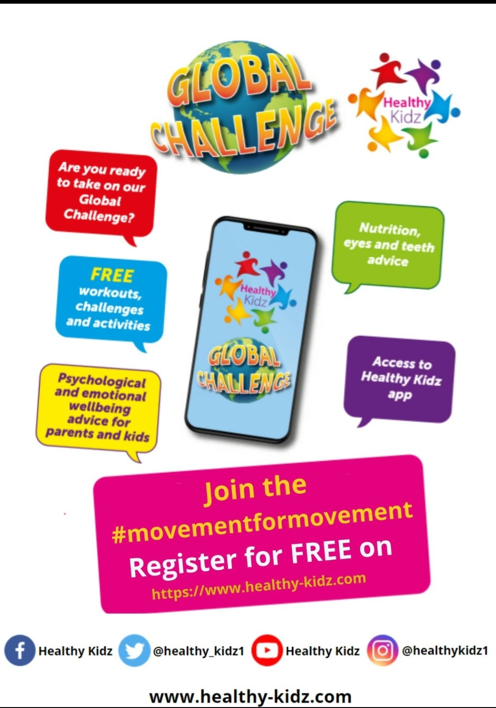

Go to the website above and link below to find out more.

https://healthy-kidz.com/healthy-kidz-global-challenge/

