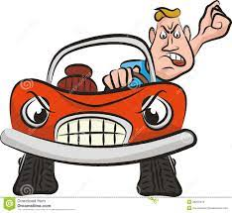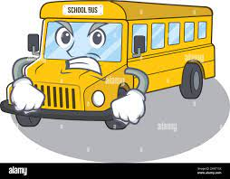

Dear Parent(s)/Guardian(s),
Since we returned to school there have been ongoing challenges each morning caused by a small number of our parents who insist on parking in the designated bus bay.
Part of the bus driver’s duty is to ensure every child is able to disembark from the bus in a safe manner. He has been unable to carry this out due to the cars and vans who insist on parking in the bay.
When this happens, the bus has to draw to a halt alongside the cars parked in the designated space. This results in our pupils having to weave their way through cars to access the pavement and the traffic behind the bus having to stop and wait until all children have exited.
I also have to leave the yard to ask parents to move on to allow the bus to pull in, ensuring safety for our pupils.
While I know it might be tempting to park in the bay as you feel you will only be a minute, I am respectfully asking you not to. This thoughtless action results in a frustrated bus driver, a frustrated principal, other frustrated drivers behind the bus and most importantly, our children’s safety being compromised.
Please refrain from parking in the bus bay and help get people’s day off to a better start.
Thank you.
Pauline McEvoy
Principal

