The New School Term 2023

Dear Parent(s)/Guardian(s),
I hope you have all had a restful and relaxing holiday but as you know, September 1st is just around the corner. Below, I have outlined a few key points and reminders to help you get organised for the return to school.
The children from P.2 to P.7 will return on Friday 1st September. The Nursery and P.1 children have been given their own separate start dates.
Morning
The school day begins at 9.00am. Parents can drop their child(ren) off at school from 8.45am where they will be supervised in the yard until their teacher collects them at 9.00am to bring them to class and begin their day.
Breaktime
We will continue to have three breaktimes for this school year. This will bring composite classes together, allowing complete year groups time to play together. Your child’s breaktime snack must be healthy – milk/water/fruit/veg.
- P1, P1/2 and P2 will break at 10.15am.
- P3, P3/4, and P4 will break at 10.30am.
- P5, P6, P6/7 and P7 will break at 10.45am.
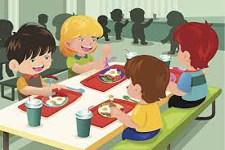
Lunchtime
There will be two sittings at lunchtime. P1, P1/2, P2, P3 and P3/4 will have lunch at 12 o’clock. P4, P5, P6, P6/7 and P7 will break for lunch at 12.30pm. Both children taking dinners, and those taking lunches, will eat in the dinner hall.

Children will continue to use the separate entrances and exits when arriving and leaving school. I will remain in the yard for the first few mornings to assist anyone arriving late.
We will continue to encourage good hand hygiene and we remain cognisant of social distancing as the instances of covid are increasing.
We are asking that senior children come to school in full uniform, including plain black shoes. PE uniforms, including trainers, are only to be worn on the day(s) the children are having PE. The children will be told their PE day(s) as soon as possible.
In short :
P.3 – P.7 are to wear their full school uniform to school with proper black school shoes. The P.E uniform with trainers, is to be worn only on the days the children have P.E.
P.1 – P.2 are to wear the P.E uniform each day along with proper black school shoes. Trainers can be worn on their P.E day. Some children may prefer to wear the formal uniform. This is also acceptable but must be worn with black school shoes.
Nursery children wear the P.E uniform and can wear trainers every day to school.
Please label all items of uniform.
Morning club will be available from Monday 4th September. After school club will be organised as quickly as possible and we will be in touch to let you know when it, and our homework club, begin.
As far as we know, dinners remain at £2.60 per day, £13.00 for the week. This must be paid via Parentpay.

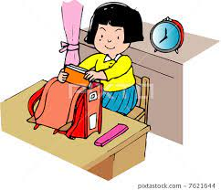

Transfer Classes
These will resume on Monday 11th September. The children involved in these classes will be given a schedule for term one on that day.

New School App
Our new school app will soon be available to download. All documentation will be sent via this app. It is essential that you download it as no hard copies of documentation will be sent home nor will any further communication be posted on the school website. The website will remain as a window into the school to allow families insight into our school life; the school app will be for all communication and documentation. We will be in touch when the app is ready to download.

Enjoy the remaining days of the holidays and we look forward to seeing you all on Friday 1st September.
Le meas,

Pauline McEvoy
Principal

