Dear Parent(s)/Guardian(s),
This year some of our classes will be joining together and performing a Christmas play. These performances take place on Thursday 15th December at 10am and at 2.00pm.
P4/5AMcC and P5SK will be performing ‘I’m Gonna Shine!’ at 10am.
P6GD, P6/7EN, P7NMG will be performing ‘No One Wraps Like an Elf!’ at 2.00pm. Both performances will be in the assembly hall.
Doors open at 9.30am and 1.30pm respectively and there will be a cup of tea/coffee and mince pie reception to welcome you to the performance. The doors will close promptly at 10.00am and at 2.00pm as the performances are being recorded.
Everyone is welcome to attend. It does not matter if you do not have a child in the classes involved. As members of our school community, everyone is welcome to be a part of the Christmas spirit. There is no admission fee but there will be some festive buckets at the door for any donations towards school funds. There will also be a quick raffle at the end of each performance.
Preparation for these productions has already started and the coming weeks will be busy with rehearsals and organising costumes. Lines will need to be learned and songs will need to be practised. As a result, from the week beginning December 5th, homework for the classes involved in the productions will be based on preparation for their show.
Homework for the other classes will also be reduced from this date to reading and spellings and some ‘learning’ work. This is to reduce pressure at home as we all prepare for Christmas. There will be no homework from December 12th.
Please do not go to any expense for costumes – old shirts, bathrobes, tea towels are all acceptable!
We are asking that no digital recording devices are brought into the hall in line with our Child Protection Policy. A recording of each performance will be available on request from the school.
On Friday 16th December, the school will have its Christmas dinner. We are asking that all children are collected at 1.00pm on this day. The younger pupils can be collected from 12.45pm. Only the Nursery morning session will in school on this date. This will allow staff to come together and have Christmas dinner with Mr Gerry Barry, to mark his retirement from St Malachy’s P.S.
On Tuesday 20th December, our school council has organised a school Christmas disco for the children. This will be during the school day and more details will follow.
As you can see, December will be a very busy month but we are really excited to be getting back into the Christmas spirit and welcoming you all to our shows.
We are looking forward to seeing you there.
Pauline McEvoy
Principal

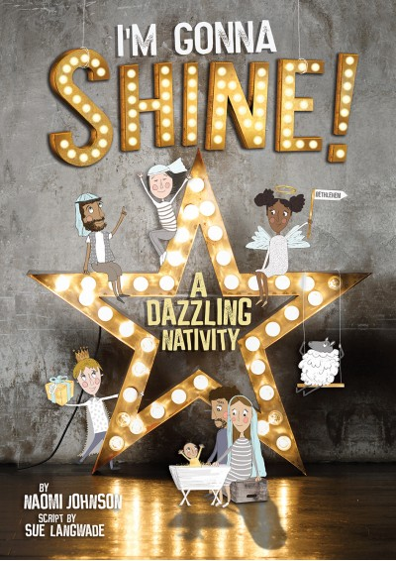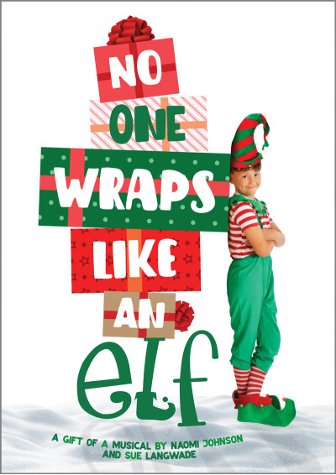
‘We pray, we love, we learn, we grow. Together.’

