Primary Two (Mrs McAnulty) Curriculum Overview: Term 1
General Information | - Children should wear their coat to school every day, particularly in the Autumn and Spring Terms. Please ensure your child’s coat and jumper is clearly labelled with their name.  - Please ensure that all homework is completed and signed along with the reading record. Use pencil for written answers.  - All water bottles or other personal belongings must be labelled clearly with your child’s name and class.
Religion | Primary Two ‘Grow in Love’ Scheme completely in weekly sessions. Grow in Love homework will be sent home every Thursday.  Encourage your child to bless themselves properly and to say their prayers clearly.  The following themes will be completed in Term 1:  Theme 1: Our World  Seasonal Lesson: We Remember  Theme 2: We Belong  Theme 3: Advent and Christmas
Literacy  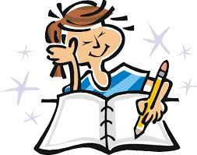  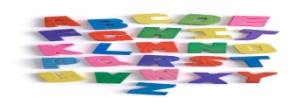 | Linguistic phonics & Cross Curricular ideas to coincide with WAU.  Reading  Children will listen to and retell stories, they will be encouraged to summarise, comment on pictures, predict outcomes and improvise.  Children will read familiar simple stories and poems, using expression and intonation. Children’s talking and language skills will be developed through role play, reciting rhymes, re-enacting stories, describing personal experiences and story settings.  Approaches to reading: Guided reading, shared reading- at home/in school, Independent reading.  Children can take a book home from the classroom Library each week (enjoy a book together –read to them and/or share the reading-let them tell the story) READ EVERY NIGHT. Rigby Star/Oxford Reading Tree/Oxford Literacy Web reading schemes will be used as guided reading texts, a familiar reading text will also be sent home to encourage independent reading. Please encourage strategies as noted inside book cover.  Writing  Children will experience writing simple sentences, captions, labels and lists. They will understand and use the term sentence using a capital letter for the start and proper punctuation.  They will write captions for their work, make simple lists and write and draw simple instructions.  Children will be encouraged to use correct formation of lower case letters, working on their practice using the Nelson Handwriting Scheme.  Children are exposed to a range of different genres of writing.  Phonics  Children will work on their ability to rhyme. Pupils secure their knowledge of initial sounds and be able to use these sounds to write CVC words independently by segmenting and blending (decoding skills).  Children will read on sight high frequency words and recognise the critical features of words.  Useful websites for Phonics /High frequency words: www.roythezebra.co.uk, www.phonicsplay.co.uk, www.ictgames.co.uk, https://www.starfall.com/h/ltr-classic/  The YouTube channel ‘Mr T’s phonics’ is also helpful for developing phonological awareness, segmenting and blending.

Numeracy  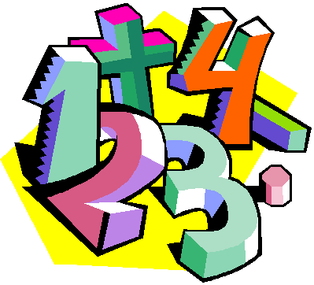 | Collins – New Primary Maths scheme.  In Term 1 children will:  - Become familiar with numbers 0-20 and beyond where appropriate.  - Count orally in 1s, 2s, 5s and 10s.  - Recognise, read, and write numbers to 20 and beyond.  - Understand the term number ‘before/after’, ‘1 more/1 less’ within 20.  - Understand conservation of number.  - Be able to practically combine sets to 20.  - Be able to practically subtract objects from a set within 15.  - Use everyday language to talk about position, turns and distance  - Be able to recognise and compare 1p,2p, 5p, 10p, 20p, 5p, £1 and £2 coins. Begin to develop the concept of change in a play setting.  - Be able to order and sequence familiar events.  - Begin to use mathematical names for some 2D and 3D shapes and identify some properties.  - Be able to recognise, create and describe increasingly complex patterns.  - Use everyday language to talk about length to compare objects and solve problems. Begin to use non-standard units of measurement.
World Around Us | Topic-based approach to cover Geography, History, Science and Technology  Term 1: All about me, Autumn and The Post Office.
Art & Design | Cross curricular links to coincide with WAU and Play based learning. | Music | Cross Curricular links and Music Express Resource used.
PDMU  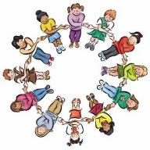 | Living, Learning, Together Year 1 resources. | PE  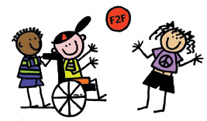 | Attainment areas of ‘Games’, ‘Gymnastics,’ ‘Dance’ and ‘Athletics’ will be delivered.  Pupils will develop their balance, co-ordination and loco-motor skills.  Please ensure that your child wears their PE shoes to school on Friday.
Learning Through Play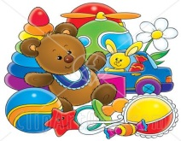 | Based on WAU Topics  Play should also build on the children’s own interests and experiences.  Children plan where they are intending to play and what they are intending to do, and follow through on their plan.  Children will have opportunities to report to their class about their play experiences during ‘Play Reporter’ time.

