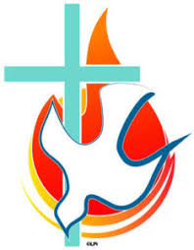

Confirmation will take place on Tuesday 29th March 2022. It will be at 3.30pm in The Church of the Good Shepherd.

Further details, regarding numbers allowed etc., will be sent to you nearer the time.

