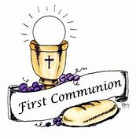

The Sacrament of First Holy Communion will be celebrated on Saturday 14th May 2022 at 11am.

We hope to be able to have the ceremony in St Malachy’s Chapel, but this will be dependent on the guidance at the time.

We will continue to keep you informed.

Pauline McEvoy
Principal

