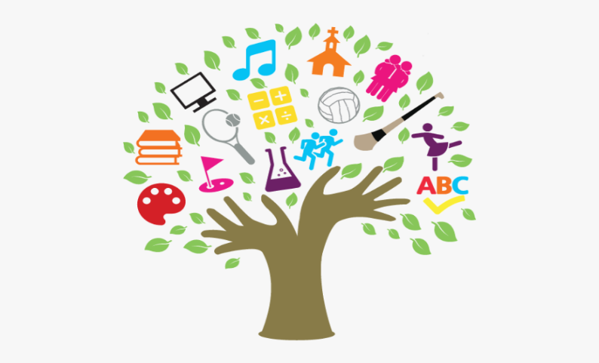

Dear Parent(s/Guardian(s),

In the surveys carried out at the end of last year, many of you told us that you would appreciate being kept informed of the topics/concepts your child(ren) will be learning each term. Having this information will help you to plan and resource the crucial support you give your child(ren) at home.
Next week each teacher will post their curriculum overview for term one. In this overview, they will outline the topics and concepts that will be taught in each curriculum area for their specific class.
There will be a second overview posted in term two and a third and final, in term three.
You will find this information in the Home Learning tab, under your child’s class.
We hope you will find this document informative and useful.

Pauline McEvoy
Principal

