Helping Your Child With Comprehension.

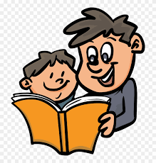

This year, one of our targets in literacy, will be developing key comprehension skills in our pupils, from P.1 to P.7. This is a crucial skill for life-long learning. Your child may be able to decode a piece of text, but our aim is to build on that foundational skill. Comprehending what they are reading, is a much more complex skill set for your child to master and it plays a key role in every other subject area including mathematics and the sciences.

To help us achieve this target, your child’s teacher will be receiving specialised training in the coming weeks from Mrs Kate O’Hanlon, an expert in this area.

We also need your help, and so, for advice and guidance, there will be an online workshop session via Zoom for our parents on Monday 27th September at 7.30pm delivered by Mrs O’Hanlon.

The link to the session will be posted on our website, in the Home Learning tab under any of the classes on that Monday.
We hope you will be able to attend this workshop. We look forward to seeing you there.
Pauline McEvoy
Principal

